Information report: Sportacus 10

***Oliver K. Tshiamala***

**Introduction (Welcome to LazyTown)**

**I have been waiting since forever to do this, and now I finally have the time. Today I’m gonna tell you all about Sportacus 10 even though he’s not an animal.**

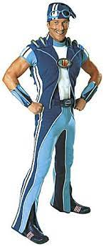**Introduction 2 (School Scam)**

**Sportacus 10 is the superhero of LazyTown and used to be an elf as Iprottalfurrin (accurate translation: The Sports Elf) back in Afram Latibaer (accurate translation: Go LazyTown) and in Glanni Glaepur i Latabae (accurate translation: Robbie Rotten in LazyTown) until 2002, where the Latabaer era (1995-2000) ended and the LazyTown era (2002-2015) started. He is still an elf in the Icelandic dub of the show, but not in other countries/languages/dubs.**

**Appearance (Costume)**

**Sportacus has a pencil moustache and a blue outfit with blue and black boots. Starting from Season 3 Episode 1 “Roboticus” he has a backpack which he can fit in fruits, veggies and his sky chaser. He has goggles, a hat, and a belt saying “S” standing for Sportacus.**

**Habitat (Home)**

**Sportacus lives in a blue airship above LazyTown in Iceland and has before the events of the first episode. In this airship he keeps most of his stuff in it. Like books, sports equipment, and even an installed-in bed. He can also ride this airship and exits it and enters it by saying “ladder!”**

**Diet (Sportscandy)**

**Sportacus eats a lot of Sportscandy which is just fruits and vegetables. Nothing else, though. In Season 1 Episode 3 “Sports Day” he tells the kids that he used to eat sugar and his energy drained, then Robbie tricked him with a sugar apple. In Season 2 Episode 12 “Birthday Surprise!”, Robbie Rotten catches an apple Sportacus called for, then replaces it with a sugar apple. In Season 4 Episode 12 “Robbie’s Dream Team”, he also gets tricked into eating a sugar apple from Robbie disguised as an old lady. In Afram Latibaer, he is seen lecturing Jives about the healthy way to eat meat, which means Ipprottalfurinn could have formerly eaten meat.  
Real Name (woah)**

**According to a 2002 article on lazytown.com, Sportacus is the son to Bessie Busybody (which is weird because Sportacus calls his *MOM* by her first name) which confirms his last name, Busybody. According to a 2003 article about the origin/story of LazyTown, Sportacus’ real name is Alex. Sportacus’ real name is Alex Busybody. His full superhero name is Sportacus 10, meaning he isn’t the first Sportaflop.**

**Goodbye lol (Bing Bang Diggawiggadong)**

**Thank you, reader, for being a good reader and goodly reading this good readable text that is mean readably meant to be read. If this was a text about Stephanie, I would have copied and pasted the whole lyrics to Bing Bang.**

**Info report © 2022 Oliver K. Tshiamala**

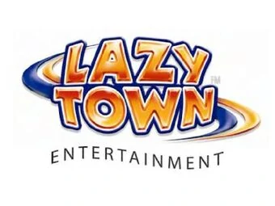

**Artwork 2004 LazyTown Entertainment**

**LAZYTOWN © & TM 2004 LAZYTOWN**

**ENTERTAINMENT**

**LAZYTOWN, SPORTACUS AND ALL RELATED TITLES,**

**LOGOS AND CHARACTERS ARE TRADERMARKS OF**

**LAZYTOWN ENTERTAINMENT**

**LAZYTOWN PROGRAMS, CHARACTERS,**

**STORYLINES AND OTHER RELATED ELEMENTS ©**

**2004 LAZYTOWN ENTERTAINMENT**