An Ode to LazyTown

LazyTown

It is a show I enjoy

Is it true?

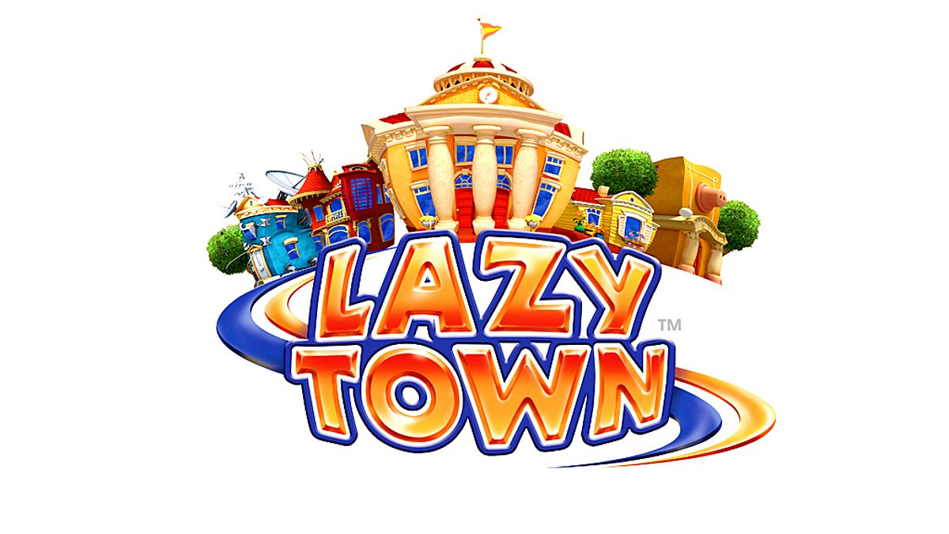Well, doy!

Sportacus 10

He lives in a blimp

A flipping superhero

And isn’t a wimp!



1: Sportacus in Season 2, Episode 1. Most active resident in the town. Superhero who lives in an airship and only has one weakness – sugar. Everyone was lazy until he came to the town. 'Rockin Robbie' copyright Magnus Scheving.

Robbie Rotten

The master of disguise

He’s a huge softie

And he tells a lotta lies!

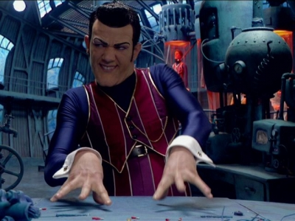

2 - Robbie Rotten in Season 1, Episode 2. Laziest resident in town who lives in an underground lair. Always using disguises and inventions to try and get Sportacus out of town, and/or everyone lazy. ‘Defeeted’ copyright Magnus Scheving.

Stephanie Splitz

She’s got pink hair

She always dances

No matter where!



3 Stephanie Splitz in Season 1, Episode 10. Came to LazyTown for the summer, then ended up staying. Girl who owns a lot of pink stuff, and enjoys dancing. Out of all the kids, she takes Sportacus' messages and tries to implement them in her healthy lifestyle. Becomes a superhero in the hour-long season one movie, but also saves people in season 3 and 4. ‘Lazy Scouts’ copyright Magnus Scheving

Ziggy Zweets

Obsessed with taffy

Kinda dumb

But always happy



4 Ziggy Zweets in Season 1, Episode 27. Wants to be a superhero like Sportacus, but always eats candy. Is the youngest LazyTowner. ‘LazyTown’s New Superhero: Part 1’ copyright Magnus Scheving.

Pixel Hyperbyte

A complete tech nerd

Has a crush on Stephanie

And he hasn’t told her

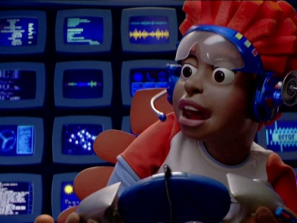

5 Pixel Hyperbyte in Season 1, Episode 2. Uses technology a bit too much. Owns a website called Pixelspix with all LazyTown residents excluding Robbie.

Stingy Spoilero

He has a lot of money

Claims a lot of stuff

And his voice actor’s really funny



1 Stingy Spoilero in Season 1, Episode 2. His favourite colour is yellow, he is very organized and is also very selfish. His best friend is a piggy bank and the rest of the LazyTowners. Defeeted copyright Magnus Scheving

Trixie Troubleby

She’s very mean

Owns a cool scooter

And always makes a scene



2 Trixie Troubleby in Season 1, Episode 18. Her best friend is Trixie, she likes scootering, and she is mean to the LazyTowners sometimes. She calls Stephanie Pinky. Records Day copyright Magnus Scheving.

Mayor Meanswell

He’s really clumsy

Uncle of Stephanie

Has a huge tummy

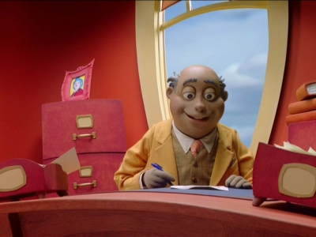

Mayor Milford Meanswell in Season 1, Episode 10. He is the bumbling and clumsy mayor of LazyTown and uncle of Stephanie. Lazy Scouts copyright Magnus Scheving

Bessie Busybody

Thinks phone calling is fun

Kinda bratty

And she gets the job done!

With the help of Milford.



3 Bessie Busybody in season one, episode fifteen. A woman of fashion who practically uses Milford to fix up her house and carry her stuff. Laziest Town copyright TimeWarner.

Oh yes, it’s true

I love LazyTown

It’s funny, creative

And turns my frown upside down



The only kids show

Focusing on healthy lives

Sportacus captured the heart

Of a million housewives

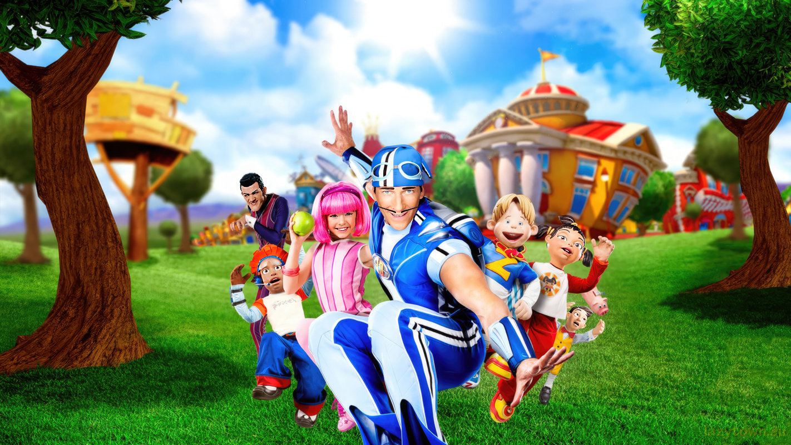

Millions of watchers

About LazyTown, they’ve heard

Magnus Scheving always says

‘Let’s move the world!’

