

[Date]

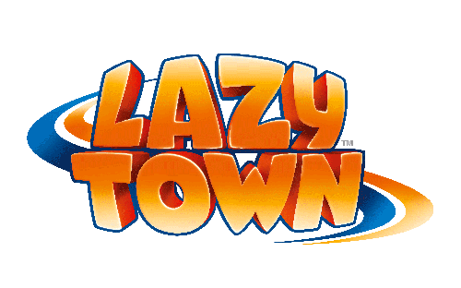

**LazyTown Series 3 goes into production with new adventures, new gadgets – and a new Stephanie!**

Award-winning children’s TV series LazyTown is back in production for a third series of brand new 13 half hour shows following its acquisition by Turner Broadcasting in September 2011.

Charting the adventures of action hero Sportacus, aspiring dancer Stephanie, resident villain Robbie Rotten and the rest of the LazyTown gang, the show once again stars its creator Magnus Scheving as Sportacus, with a new actress in the role of Stephanie.

Ten-year-old **Chloe Lang**, from Connecticut in the US and already a successful competition dancer, takes over from Julianna Rose Mauriello as Stephanie, the show’s lead female character, who is much loved by children for her bright pink hair, sunny disposition and dancing skills.

“I‘m happy and honoured to take on this role and very excited to have the opportunity to live in Iceland for the next few months and work with the LazyTown crew,” says Chloe. “ I have always looked up to Julianna - she was great on the show and I just hope I can perform to her standards.”

Created as a concept nearly 20 years ago by Magnus Scheving, LazyTown is the only global entertainment brand dedicated to kids’ health. Its aim is to motivate kids and their families to make positive lifestyle choices in a fun, entertaining and inspirational way.

As well as the TV show, the brand encompasses live shows, music, games, radio, publishing, retail and community initiatives such as marathons, sports clubs, meet ‘n greets and government-backed healthy eating campaigns.

“I’m really excited about filming the new series, not least because Sportacus has got some really cool new gadgets to help him in his mission to get kids active and having fun in a creative way,” says Magnus.

Filmed as usual in the LazyTown Studios in Iceland, the special effects are being created this time round by Turner Studios in Atlanta, whose credits include Ben 10, Level 10, Matrix and X-Men.

The new series is being produced by Magnus Scheving and Björn Thorir Sigurdsson and directed by Magnus Scheving and Sigvaldi J. Karason.

“LazyTown is one of the most powerful kids’ brands in the world,” says Turner’s Chief Content Officer for EMEA Michael Carrington. “It’s not only great entertainment, but – thanks to Magnus – has had a huge impact on society’s fight against childhood obesity. The new TV series promises to be even bigger and better than before and will play an important role in our plans to build up and extend our pre-school channel Cartoonito.”

The first two series of LazyTown have also been acquired by Turner and will be transmitted on Turner channels internationally before the new series airs in early 2013.

Further information

XXXXXXXXX

**About Turner Broadcasting**

Turner Broadcasting System (TBS) Europe currently broadcasts 18 channels in 26 languages in over 130 countries in Europe, the Middle East and Africa (EMEA). Turner Broadcasting brands currently operating in the region include Cartoon Network, Boomerang, Cartoonito, CN Too, TNT, Boing, Adult Swim, TCM (Turner Classic Movies) and CNN International. In EMEA the company is at the forefront of innovation and development, with its brands available to audiences across the region via the web, VOD, DVD, gaming, mobile, merchandising, publishing and emerging platforms. Turner Broadcasting is a Time Warner company.

**About LazyTown**

LazyTown is a children’s entertainment brand dedicated to promoting health and wellbeing in a fun way. Created and starring Icelander Magnus Scheving, the programme has been seen by more than 500 million children and aired in over 170 countries throughout the world. LazyTown is currently collaborating with various government agencies worldwide on developing far-reaching and impactful health initiatives and has aligned with likeminded organisations such as Change4Life, the US Soccer Foundation and Mediterranean Diet.

**About Cartoonito**

Cartoonito is a pre-school channel where young children can explore their world in a fun and imaginative way. Cartoonito airs an array of exciting pre-school programmes including LazyTown, Bananas in Pyjamas and Jelly Jamm. Six cute animated characters called the Cartoonitos introduce the shows. Cartoonito is a channel in the UK, Italy and Spain and is shown as a branded block on Boomerang or Cartoon Network in other Turner EMEA regions.